CREATING A FORM PROJECT
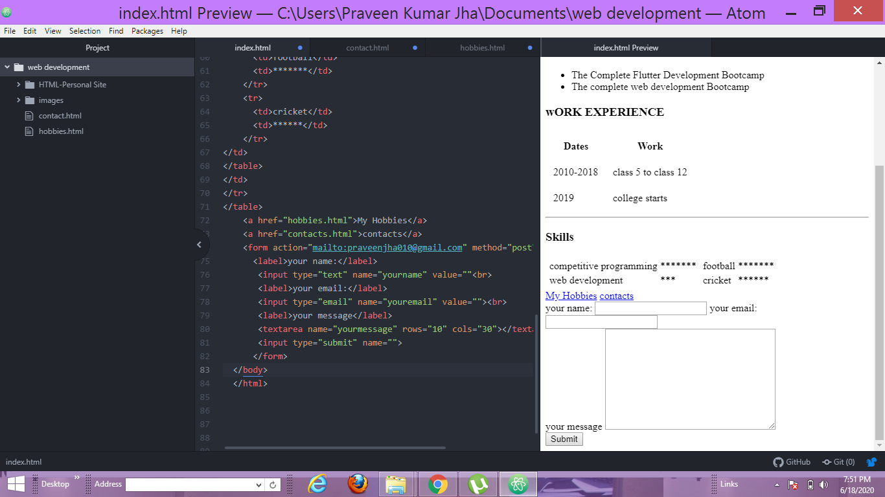
<form action="mailto:praveenjha010@gmail.com" method="post" enctype="text/plain">
<label>your name:</label>
<input type="text" name="yourname" value=""<br>
<label>your email:</label>
<input type="email" name="youremail" value=""><br>
<label>your message</label>
<textarea name="yourmessage" rows="10" cols="30"></textarea><br>
<input type="submit" name="">
</form>

